Action-research using Participatory Video. A learning experience in San Lorenzo, Castellón, Spain.

Investigación-acción a través del Video Participativo. Una experiencia de aprendizaje en San Lorenzo, Castellón, España.

Abstract

The aim of this paper is to analyse a participatory action research process undertook in the neighbourhood of San Lorenzo in Castellon – Spain as part of a Summer School in 2014. Participatory Video (PV) was used to introduce action learning amongst international students, to visualize the work of local practitioners and to give voice to the local community. To undertake this analysis an original framework is developed (the ePARC cube). The cube features three axis that represent the main dimensions the PV process touches upon 1) participation 2) knowledge and 3) public deliberation. From this three dimensional perspective, we argue that a genuine participatory process raises issues that often cross-cut. We conclude that to take full advantage of the momentum a PV process could reach in a community, more engagement from policy makers to affect social change should be sought.

Resumen

El objetivo de este artículo es analizar una experiencia de investigación-acción participativa desarrollada en el año 2014, en el barrio San Lorenzo de Castellón, España dentro del marco de una escuela de verano. El Video Participativo (VP) fue usado para generar aprendizajes entre los y las estudiantes internacionales participantes en la escuela de verano así como para visualizar el trabajo social de profesionales locales y amplificar la voz de la comunidad. El artículo presenta un nuevo marco de análisis, el “Cubo ePARC”, para identificar los aprendizajes mas relevantes. Los tres ejes del cubo representan las dimensiones en las que consiste el proceso de VP 1) participación 2) conocimiento y 3) deliberación pública. Desde esta perspectiva tridimensional, el artículo sugiere que en un proceso participativo genuino se superponen muy frecuentemente estas dimensiones. El texto concluye que para sacar el máximo provecho del proceso de VP en una comunidad es necesaria la activa implicación de los responsables de políticas públicas en el proceso.

Key words

Participatory Video, Participatory Action Research, Higher Education, Practitioners.

Palabras clave

Video Participativo, Investigación-Acción Participativa, Educación Superior, Profesionales.

1. Introduction

The aim of this paper is to analyse a participatory action research (PAR) process that took place in the neighbourhood of San Lorenzo in Castellon - Spain, in June 2014. Developed as a fourteen-day Summer School, 30 students from seven different European Masters programmes focused on the development field, were brought together to listen to stories and identify powerful narratives from the residents of San Lorenzo. The students were tasked with producing a series of short videos illustrating these narratives; these videos would be shown to the community in a public screening at the end of the process.

This experience is considered a Participatory Video (PV) activity which has largely been used as a method and a process with the objective of empowering individuals and communities through sharing stories and making videos depicting their own realities, challenges and aspirations for the future (White, 2003). PV can be considered as one of the many manifestations of the relationship between media and development (Scott, 2014) and also as a tool under the umbrella of participatory action methodologies.

PV is a wide field, which allows a wide range of approaches and perspectives (High et al, 2012): some use it as a method for research (Oliver et al, 2012), while others regard it as a tool and a process to foster awareness for local communities (White, 2003; Plush, 2012). Other authors have explored it as a way to influence policy making (Wheeler, 2012), although, in the same experience, a PV process could aim to achieve more than one of those goals. According to Shaw (2013) there is neither a single nor correct method to approach a PV process and what happens in each experience is very contextual and could lead to very different outcomes.

In the context of the Summer School, PV could be considered a learning approach where the international students were the main researchers. There were also, all throughout the process, other participants involved such as the local social workers who had an active role in the production of videos as well as three facilitators, two of them the authors of this paper.

For the analysis of this experience we have developed an original framework: the Digital Participatory Research Cube (ePARC) inspired in PAR researchers such as Gaventa (2006a) and PV researchers such as Wheeler (2009), Plush (2012; 2015a) and Shaw (2013). This Cube tries to capture the different dimensions of a PV experience: the extent to which the process is meaningful and empowering for the participants, the transformative character of the knowledge produced and the public deliberation spaces opened by the process that could be influential for policy making.

In section two the main characteristics of the Summer School are presented: the context, the participants and the PV approach followed. In section three the original framework developed to analyse the experience, the ePARC, and the methodology used to analyse the experience. In section four, evidences are presented and, finally, section five discusses and reflects the authors’ lessons learnt and some conclusive ideas are suggested that could be useful for scholars and practitioners considering and using participatory digital methodologies. The authors are aware of the limitations of this analysis: it is a single case study and the core of the PAR lasted twelve days. However, the experience is unique and has some ingredients that render it interesting for analysis: the interaction between a multicultural and international group, the use of a methodology (PV) which in the local context and for the international students was absolutely new and finally, the use of the ePARC framework for analysis with the intent of building a more comprehensive understanding of a process of this kind.

2. The Summer School

2.1.The community

San Lorenzo is a neighbourhood located to the west side of the city of Castellon in Spain. It is one of the neighbourhoods with the highest indicators of unemployment and marginalisation in the city. Within its boundaries, historically, there have existed spatial conflict issues, which help to reinforce social divisions in the area. The first wave of residents of San Lorenzo arrived during the 1960s as migrant workers from different parts of Spain, they built their own houses, planned basic sanitation and mobility infrastructure, and built social spaces such as the church and the school. In the mid-1980s, six blocks of social housing flats were built under a new programme implemented by the Valencia Housing Institute. They were aimed at housing very low or no-income gypsy families being relocated from slums elsewhere. This process generated a sharp divide in the area and the lack of consultation on behalf of the housing institute in San Lorenzo, left residents with no other option than to accept the newcomers who, as gypsies, were seen by the existing community as difficult to integrate, ‘dangerous’ and ‘uneducated’. In general, they were regarded as people who did not have the same ideals and status of the first wave of residents.

Gypsies and ‘Payos’ – a word used by the gypsy community to describe anyone who does not belong to their culture– live in constant disagreement. Social spaces are divided and appropriated by specific groups. Due to this, over recent years, the local government of Castellon and local NGOs have channelled resources to fund programmes that help promote dialogue and improve the communication between the divided communities. The initiatives have been implemented by social workers that, as a result of the longevity of the programmes, have themselves become almost like residents of the neighbourhood.

The programmes developed in San Lorenzo range from teaching new skills to marginalised women and engaging with the elderly, to teaching alternative skills for youth empowerment. This on-going engagement led to the creation of ‘La Taula’, a representative structure that aims at improving the dialogue between local residents and government actors while facilitating the coordination among the initiatives being implemented. However, the context became particularly complex within the framework of the Spanish economic crisis, which combined with a social housing crisis, meant that local residents felt that they are living in constant economic uncertainty, and the local government’s attempt to reduce costs has led to massive funding cuts for social projects.

The local University, Jaume I of Castellón, has collaborated with the neighbourhood for more than 15 years undertaking various research projects with students at Masters and PhD levels. One of the on-going projects that emerged from this close collaboration is ‘Pisos Solidarios’ (Supportive Flats) which consists in providing university students with subsidised accommodation within San Lorenzo. The students, in return, offer their time to boost cultural and sporting activities or teach basic skills to young people who do not attend school.

The NGO sector is supporting an on-going gardening course in the neighbourhood. Taught in the ‘Centre de Formació Ocupacional’ and managed by the Catholic NGO Caritas Diocesana, the course offers young people, from different nationalities and ethnic backgrounds, the opportunity to not only gain employability skills in gardening but also to learn social skills and basic competences for work. As set out in the next section, these students played an active role during the Summer School.

2.2. Participants

The Summer School was structured as a combined teaching and research initiative. The principle co-researchers were the 30 students representing seven Masters programmes related to the development and international cooperation field from Italy, United Kingdom, Romania and Spain. Three academics acted as facilitators of participatory methodologies and along with other lecturers, they offered support bringing together theoretical insights on development and the community’s specific issues into the video narratives. Local lecturers facilitated the contact with local associations and were in charge of the practicalities of the Summer School, although none of them played a role as active facilitators of the process.

Other participants involved were the local practitioners working in San Lorenzo. Two of these participants were crucial all throughout the fieldwork for their substantial knowledge about the social complexities of San Lorenzo: one was the head of the Municipal Social Services in San Lorenzo and the other was the teacher of the gardening courses. The latter also encouraged her group of current gardening students to take part in the process as guides due to their local knowledge of the area. The guides helped to immerse the international students in the multi-layered dynamics of San Lorenzo. Although the authors do not consider this group of young people as co-researchers, the interaction they had with the international students was valued as a really positive impact of the PV activity (INCYDE, 2014).

2.3. Aims

The main aim of the Summer School was to use video to capture powerful local narratives that could help re-imagine the future of San Lorenzo whilst also strengthening the identity and values of its diverse residents. In addition, the process had specific goals for the participants, some explicit and some implicit. For international students, the Summer School had three main goals: 1) to familiarise them with the human development approach as a theoretical framework to understand and analyse participatory development processes in real context; 2) to acquire skills to use participatory digital technologies and 3) to be able to put them into practice in a real social context. For the local practitioners, although the initial goals were not as explicit as the ones for international students, the Summer School aimed to provide a space for discussion and reflection of their own work within the neighbourhood and to explore alternatives to continue collaborating with the local university. For the three facilitators, this project was an opportunity to expand their understanding of human development and participatory digital technologies in a real multicultural and multidisciplinary context, as well as acquiring practical knowledge about the context in order to be able to provide useful insights for future developments to the local residents and practitioners.

2.4. The PV process

As set out in the introduction to this paper, a research-led approach to PV was used, where the international students acted as the main co-researchers working on a real case scenario.

In preparation for the Summer School, facilitators, local practitioners in San Lorenzo and partners from the university got together to prioritise key themes or “entry points” that would guide the participant groups in navigating stories that could be powerful narratives for the videos. However, once the work started, groups were invited to be open and flexible with their entry points in case more relevant issues were identified during the diagnosis stage of workshop. The groups focused on five identified relevant issues: 1) Challenges associated with housing 2) potential of local public spaces to bring about social inclusion and the improvement of quality of life in the area 3) livelihood opportunities for local residents, paying particular attention to gender relations 4) education aspirations of the youth and the challenges they face in pursuing these and 5) the needs and aspirations of the elderly. All these “entry points” were related to the programmes and social activities being developed by local organizations and members of La Taula. Figure 1 below illustrates the different stages in which the process developed.

The first phase was diagnosis in which different techniques were applied (mapping, transect walks, collective interviews with the local practitioners and members of the community) to develop an in-depth idea of the neighbourhood and the specific themes to be explored through the videos.

Figure #1 around here

The second phase was planning; in this stage participants elaborated storyboards and pitched their ideas for the video narratives to the whole group including the local practitioners. By bringing together the different voices for comment and feedback we aimed to improve and enhance the narrative and to focus on particular sensitive issues that we may have not understood properly and that could have had the potential to create tensions if shown to the whole community.

The third phase was video production in which co-researchers, with the support from facilitators, recorded the images and sounds of the local community. In almost a simultaneous way, the fourth phase, curation, started. While recording, downloading and playing the images, participants would identify gaps in the information or the need to record more images which would help to visually build the narratives. Before entering the final stage, a preliminary version of videos was presented internally to the local practitioners to elicit their final comments and suggestions. With a series of five videos produced and ready to be showcased, we entered the final stage of sharing. In a public presentation in the community centre of San Lorenzo, everyone was invited to join to watch, discuss and enjoy an afternoon that we called “social integration”. In total, the Summer School lasted 12 days.

3. Framework for analysis

3.1. The ePARC cube

To conduct an analysis of this experience we will use a framework, developed in more detail in another contribution (Author, 2016), to capture the digital participatory action research process.

We identify the three axes of the ePARC as being: 1) Participation, 2) Knowledge, and 3) Public deliberation. The “participation axis” encompasses an analysis on how the co-researchers have participated in the process. As in other participatory action approaches (Gaventa and Cornwall, 2006), analysis of power imbalances is paramount. The “knowledge axis” considers the transformative characteristics of the knowledge produced. We assume that in order to be transformative this knowledge has to be aligned with some of the following characteristics: a concern with values related to social justice (participation, equity, diversity, solidarity, etc.); a multidimensional and plural vision of well-being; an understanding of the interdependences between the local and the global, between micro and macro politics; a consideration of structural conditions that hinders the possibilities and aspirations of the community, and finally; a historical analysis of those conditions. As with the participatory axis, a power analysis should be undertaken. In the knowledge production dimension, it is important those excluded voices, or voices with fewer opportunities to be heard, are included in the knowledge base (Plush, 2015a).

The last axis of the ePARC framework is “Public deliberation”. Here the main question is: what kind of public deliberation spaces is it possible to open up during and after the research process? (Wheeler, 2012). The debate on the deepening democracy issue presented by Gaventa (2006) is useful to illustrate this point. Gaventa argues that the critical challenge for democracies nowadays is how to deepen their inclusiveness and substance, especially in terms of how citizens engage within democratic spaces to create more just and equitable states and societies. In Gaventa’s view, democracy may be seen as constantly contested and under construction; the issue is not replicating one version of democracy, as a standard set of institutions and practices, but to construct and deepen democracies, which may work differently in different places, and to find the most effective entry points for doing so, based on the local contexts. Under this perspective, a relevant contribution to a PV process can be to facilitate the deliberative entry points Gaventa refers to, both in local and in global spheres.

Figure #2 around here

Figure 2 depicts the three-dimensional image which aims to illustrate how knowledge, participation and deliberation very often cross-cut. A genuine participatory process creates spaces for public deliberation and makes the knowledge created more transformative. Relevant knowledge co-created through PV enhances spaces for democratic deliberation that go beyond the timeline of a particular participatory research process. If we consider that the goal of PV is enhancing public deliberation, this would influence the way the knowledge created is disseminated and how the whole process is designed to reach this goal. We will see how these interactions happen in practice in the analysis of the Summer School.

3.2. Qualitative research methods used to collect evidences

We base this analysis on three main sources: the first one is a participative evaluation conducted by an external organisation called INCYDE, which was commissioned to look at the project from the outside perspective and provide insights on the process. They reviewed all the preparation documents including the terms of reference, interviewed ten international students, the three facilitators, five Spanish lectures and 9 local practitioners members of “La Taula”.

Secondly, a thorough analysis of the content of the five videos produced during the process was undertaken in order to identify recurring concerns raised by interviewees (These videos are available at http://globcons.uji.es/projects/global_id).

Thirdly, as mentioned previously, two of the authors of this paper were directly involved in the process. Their comments regarding the impact of the PV in themselves are influenced by their own interpretation. Nonetheless, the authors have tried to bring balance to this bias by discussing perceptions with the third facilitator and confronting them with the observations in INCYDE’s final report.

To adhere to ethical procedures, the evaluation followed an informed consent. Moreover, all the narratives considered in the production and curation of videos were permanently discussed with the local practitioners to be mindful to sensitive issues.

4. Evidences

Using our ePARC framework, we will now present our analysis of the process. Firstly, we discuss the results of the participatory axis considering the three main groups of co-researchers: international students, three facilitators and local practitioners. Secondly, we go into a more detailed analysis of the knowledge produced and see to what extent it resonates with the main elements that make knowledge transformative. Thirdly, we focus on the moments of public deliberation that were regarded by the participants as especially empowering. As we will see, the analysis of each axis interacts with the other; for instance, in participative encounters new knowledge is consolidated by the act of public deliberation and so on.

4.1. Participatory axis

4.1.2. Students

One of the issues that emerged in INCYDE’s evaluation is that students felt that they have gained a new knowledge relevant for their professional practice. They explained that they have acquired a new understanding and awareness of what participation means in practice and which are the barriers to participatory processes. Two aspects were specially highlighted: 1) the importance of having good knowledge of the context in which a PAR is going to take place and 2) allow the time to develop relations with the local community. Some of the students noted that they experienced constrains regarding those issues because “everything was too compressed and this put a barrier to understand the context, to develop a different relationship with local people and to identify the power dynamics at stake” (INCYDE, 2014). Some of the students even perceived themselves as ‘landing’ in San Lorenzo for a social experiment.

The vision of the students is confronted by the perceptions of some inhabitants of San Lorenzo. They regarded their engagement in a very positive way: they enjoyed being the main characters in the videos, being able to tell their story, and to convey their vision of San Lorenzo using the video. Some local women felt more recognized and the residents interviewed acknowledged the importance of spaces for public discussion created throughout the process (INCYDE, 2014). There was a general agreement to valuing the attitude of respect and responsibility of the international students towards the community. There is not information to further explain the negative perceptions of the process among some students, but we can relate it to possible self-criticism, frustration with the participatory process and the feeling of stress as a consequence of a very tight timeframe.

The importance of having a good command of the local language was also highlighted. The official language of the Summer School was English as it was common for all international students; this resulted in a barrier for local students to follow the theoretical explanations. For those able to communicate in Spanish and English it was a much more satisfactory experience, as they were able to act as translators between the local community and the rest of the group. However, interesting reflections from some of the students pointed out that the language barrier is a common issue in the international development field and being aware of that was already a significant learning for them (INCYDE, 2014).

Other reflections are linked to teaching and learning. Most of the students appreciated the coherent way of teaching by the facilitators (who were able to create a horizontal relationship with them, encouraged teamwork, identified tensions among the groups and acted as mediators). Some lecturers, on the contrary, followed a ‘banking’ way of lecturing making students to feel uncomfortable. However, the students were also critical about their own capacity to participate in groups and working with others to solve problems and assume tasks. For others, power dynamics inside groups were barriers for good teamwork, as it was the excessive focus on the product (the final video) instead of the process. Open attitudes, flexibility and inclusive leadership were seen as the ways to overcome these challenges.

Finally, the PV process facilitated the learning of the audio-visual language among students. Using video in participatory research challenged the students to think how to express ideas and concepts in a visual way as well as developing powerful and critical narratives. However, they acknowledged this was not always a very smooth process.

4.1.3. Facilitators and local practitioners

The three lecturers that acted as facilitators valued their experience highly, although they acknowledge it was demanding. The interactions amongst themselves, with the local practitioners and with the community allowed them to better understand the context and be aware of power dynamics and stigmas. However, dealing with the multi-actor nature of the Summer School posed on-the-spot challenges that required quick thinking and action.

The facilitators shared the common understanding of PV as a methodology that enables collaborative and participatory learning. As one of them said, ‘PV offers an affordable technology that is appealing to people and opens new communication possibilities at a more global scale’ (INCYDE, 2014). They valued PV for its potential to integrate many people at different stages of the process. For example, the students enhanced their technical abilities using PV; the local practitioners expressed their opinions and provided feedback, and the local community shared their stories and heard of others.

Other key learnings underlined were: to have became familiar with the intersection between human development, participatory methods and digital technologies; to be more aware of the links between local and global relations that digital technologies can open up and; to translate knowledge informed by practice into theory and vice-versa.

The local practitioners also had a positive evaluation of the Summer School. They acknowledged to have enhanced their ability to engage with a multicultural and diverse group. Also, they learned another participative method to interact with academia, government and civil society. The use of video was perceived positively because it had been able to respectfully convey the messages people wanted to transmit. They commended the involvement of the youth, being trained in gardening, in the welcoming and guidance around San Lorenzo to the International students. Also, local practitioners valued the presence of the international students in the area as “it was an opportunity to see other faces, hear other languages, and get familiar with other realities […] this could enable openness, respect for the differences and commitment from the residents” they said. (YNCIDE:2014).

Finally, we argue that for some of the local practitioners, the Summer School was especially powerful to reposition their professional practice. One of the social workers admitted that the PV process challenged her to rethink her own narrative about gypsies and non-gypsies, questioning her own reflections on diversity. Local practitioners recognised that this experience has enabled an exchange of knowledge of a different kind between the local university, the community, and them as practitioners.

4.2. Knowledge axis

Five videos where produced during the Summer School: “Ven a vivir a mi barrio” (Come and live in my neighbourhood); “Sembrando” (Sowing); “Aspiraciones de las mujeres” (Women’s aspirations); “Aprendiendo del pasado” (Learning from the past) and “Voces de la juventud” (Voices of the youth in San Lorenzo). Even though each video follows different narratives, all of them depict an honest account of the everyday challenges of local residents (mainly gypsies) and of practitioners and educators working in San Lorenzo. They offer a positive view of the neighbourhood, deeming it is a good place to live because of the collaboration, friendship and social relations among residents. This counteracted the outsiders’ perspective of San Lorenzo as a violent and insecure place. While local conflict is still a reality, we deliberately chose not to portray it in a direct way but instead tried to look for indirect manifestations of the issue in everyday practices of the residents. So that, when locals saw the videos, they could have the chance to reflect upon and look for connections that underline the issue

Another narrative central to one of the videos is the lack of opportunities to access the labour market especially by young male gypsies. There is also a general concern among boys who feel they are discriminated in their opportunity to get a job due to their ethnic identity and among girls who see very few opportunities available to them to pursuit an university degree, which in some cases is also seen as a way to escape early marriage and child bearing.

There was also a general acknowledgment that education is a way to increase professional opportunities and gain self-esteem, build discipline, confidence and respect. The young gypsies felt proud of their cultural identity and of their ability to play, dance and sing, however, the songs’ words would often speak of gypsies as drunk and violent people, which help to reinforce the general image that non-gypsy people have of them. ‘Nobody is expecting anything from gypsies” said one of them in the video.

4.3. Public deliberation axis

The PV process created spaces where different voices and perspectives were heard. The moments of interaction among the international students and the facilitators were useful for reflecting on human development in practice. The assemblies and collective interviews with practitioners and the local residents produced interesting exchanges with the university group on future programmes for San Lorenzo. The interviews conducted for the videos where all technical equipment was present also sparked different level of conversation and interaction among those involved.

However, one of the most important and powerful moments of the Summer School was the final public screening. As the reader can see in illustration 1, a broad representation of the community came together to watch the videos. One of the local practitioners pointed out that for some members of the gipsy community, this had been the first time in their lives attending a public event in a place regarded for non-gipsies and to have been warmly welcomed by them. During the screening, they felt proud to have their voices heard by local policy makers, also invited to the event, and by the international students and scholars who have came from different parts of the world. This moment also marked an important precedent for local practitioners who, after working for many years in San Lorenzo, obtained public acknowledgment of what they have being doing. In a very emotive way, one of them commented: “It was a dream, I have been working in San Lorenzo for more than twenty yea […]I was really happy to see my students and the neighbourhood participating […] it is really exciting to see the videos with people from outside….it gives us life and energy” (Public screening video available at https://www.youtube.com/watch?v=zKfv0CD0bkI).

Illustration # 1 around here

4.4. Discussion and Conclusions

From what we have described above, we consider that it is in the participatory axis where more relevant results of the process are found. We have seen how the main participants expressed to have developed a new practical and experiential knowledge on several aspects regarding participation, digital technologies, education and working in intercultural context, etc.

For facilitators and local practitioners the process instigated a deep reflection on their professional practice, ‘an awareness process’ as defined by Gaventa and Cornwall (2006), which is also a relevant impact of a PAR and PV experiences (Plush, 2012; Yang, 2012). Among the students, we have appreciated a different level of reflexivity; for some them the process illustrates clearly the characteristics of a real development context, where language barriers, power imbalances, poor diagnosis, time constraints are common. For others, all of them were identified as obstacles to produce videos without establishing links with development practices.

The knowledge axis shed lights and cast shadows of the PV process. On one side, the videos included features of transformative knowledge. Firstly, because the most prominent voices in the narratives are of those who are often unheard. Also, they revealed a multidimensional understanding of what quality of life means for young people in San Lorenzo. On the other side, some voices went unheard due to time constrains and the very nature of the video setting (which very often makes people nervous and embarrassed to talk in front of a camera). In addition, in most of the videos we perceived a “naïve” impression of the community with no reference to historical and structural constrains of the neighbourhood.

However, we should acknowledge that this positive and “naïve” outlook of the neighbourhood was developed through conversations and discussions with local practitioners. They emphasised the importance of transmitting a positive view of the neighbourhood as a way to challenge stigma from outside as a dangerous and dirty place and enhance the sense of belonging among residents.

With regards to the public deliberation axis, even though we have described how the Summer School nurtured moments of public discussion and debate, we believe that the potential for tighter relations between practitioners and the local university could have been further explored. Apart from the videos, the production of policy and practical recommendations based in the evidence collected during the process and endorsed by the universities participating in the project, could have been helpful to opening spaces of discussion with local authorities and policy makers outside San Lorenzo, however we don’t have the record that this has happened.

Why hasn’t it happened? As it is described by Plush (2015b) in many cases PV processes don´t show a longstanding commitment with local communities. Although in our case, this obstacle could have been overcome with the long-term relationship between the local university and the local practitioners. Due to many reasons, we can appreciate a different appropriation of the process from local academics to that of the three facilitators. The first were in charge of logistics but were absent from the main stages of the PV process. The lack of a good command of English was one of most evident reasons, but perhaps a different expectation of a PV process was a contributing element that could explain the different level of engagement.

What we have learnt from our experience is that long-standing commitment to local actors is essential. Of course this may not be enough, as many other factors can be influential in changing policy, but it is a crucial ingredient towards social transformation.

To conclude, we have shown how a PV process could be helpful to co-create practical and experiential knowledge among participants, as well as to foster skills and abilities to take part in a PAR process. We have also reflected on the main narratives of the videos produced and highlighted how they presented a positive vision of the neighbourhood sometimes obscuring other historical and structural constrains. We have pointed out that although public deliberations spaces were nurtured during the process, an opportunity towards a more political engagement with local authorities has been missed. Finally, the use of the ePARC framework has proved to be an effective analytical tool to develop a more comprehensive understanding of the different dimensions of a PV process.

References

AUTHOR (2016)

GAVENTA, J. (2006). Triumph, Deficit or Contestation? Deepening the ‘Deepening Democracy’ Debate, IDS Working Paper 264. (http://mobile.opendocs.ids.ac.uk/).

GAVENTA, J. & CORNWALL, A. (2006). Challenging the boundaries of the possible: Participation, knowledge and power. IDS Bulletin, 37(6), 122-128. DOI: 10.1111/j.1759-5436.2006.tb00329.x

HIGH, C., SINGH, N., PETHERAM, L., & NEMES, G. (2012). Defining Participatory Video from Practice. In E. J. Milne, C., Mitchell, & N. De Lange (Eds.), Handbook of participatory video. (pp. 35-48). Lanham, Md: AltaMira Press.

INCYDE (2014). Evaluación de ‘Global Identity through Human Development: Summer School on Participatory Research Video’. Bilbao: INCYDE (Iniciativas de Cooperación y Desarrollo).

AUTHOR (2014)

OLIVIER, T., DE LANGE, N., CRESWELL, J.W., & WOOD, L. (2012). Mixed method research in participatory video. In E. J. Milne, C., Mitchell, & N. De Lange (Eds.), Handbook of participatory video. (pp. 131-148). Lanham, Md: AltaMira Press.

PLUSH, T. (2012). Fostering Social Change through Participatory Video: A Conceptual Framework. In E. J. Milne, C., Mitchell, & N. De Lange (Eds.), Handbook of participatory video. (pp. 67-84). Lanham, Md: AltaMira Press.

PLUSH, T. (2015a). Participatory video and citizen voice – We’ve raised their voices: is anyone listening? Glocal Times, 22/23, 1-16, September 2015 (http://ojs.ub.gu.se/ojs/index.php/gt/issue/view/418).

PLUSH, T. (2015b). Interrogating Practitioner Tensions for Raising Citizen Voice with Participatory Video in International Development. Nordicom Review, 36 (2015) Special Issue, 57-70 (norden.diva-portal.org/smash/).

SHAW, J. (2013). Using Participatory Video for Action Research. Real Time. (real-iime.org.uk).

SCOTT, M. (2014). Media and Development. London: Zed Books.

WHEELER, J. (2009). ‘The Life That We Don't Want’: Using Participatory Video in Researching Violence. IDS Bulletin, 40(3), 10-18. DOI: 10.1111/j.1759-5436.2009.00033.x

WHEELER, J. (2012). Using Participatory Video to Engage in Policy Processes: Representation, Power, and Knowledge in Public Screenings. In E. J. Milne, C., Mitchell, & N. De Lange (Eds.), Handbook of participatory video. (pp. 365-382). Lanham, Md: AltaMira Press.

WHITE, S. A. (2003). Participatory video: Images that transform and empower. New Delhi: Sage.

YANG, K-H. (2012). Reflexivity, participation, and video. In E. J. Milne, C., Mitchell, & N. De Lange (Eds.), Handbook of participatory video. (pp. 100-114). Lanham, Md: AltaMira Press.

Figure 1 : Stages of Participatory Video Development.

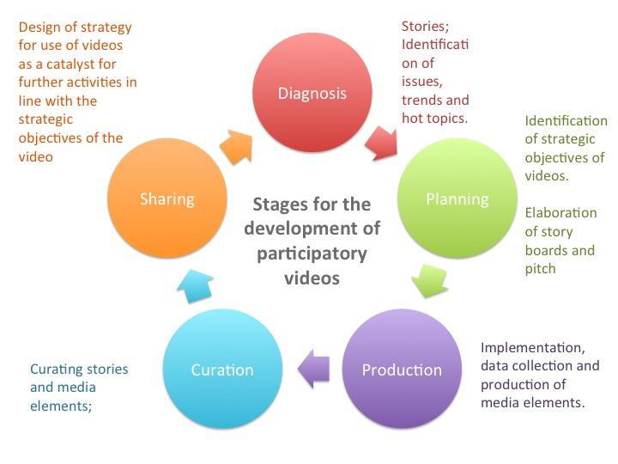

Source: Authors
Figure 2: The ePARC framework

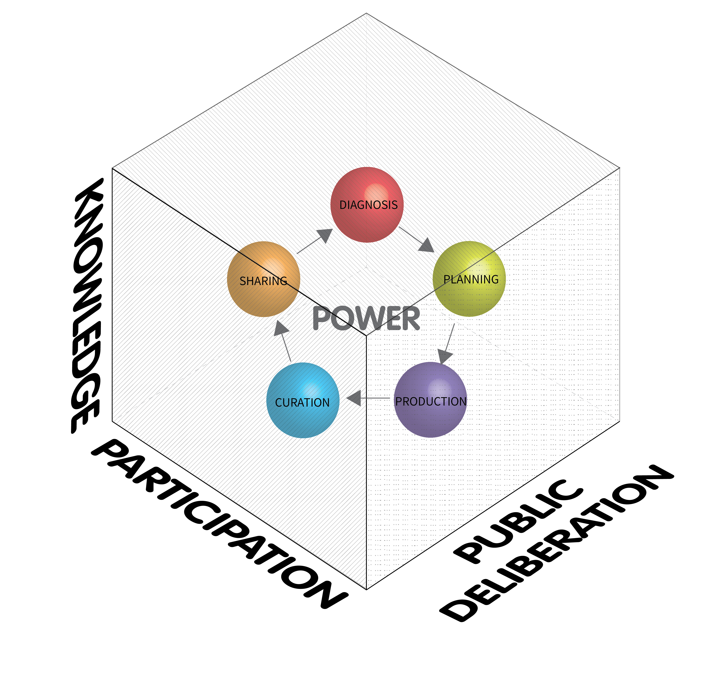
Source: authors

Illustration 1: Public screening in San Lorenzo

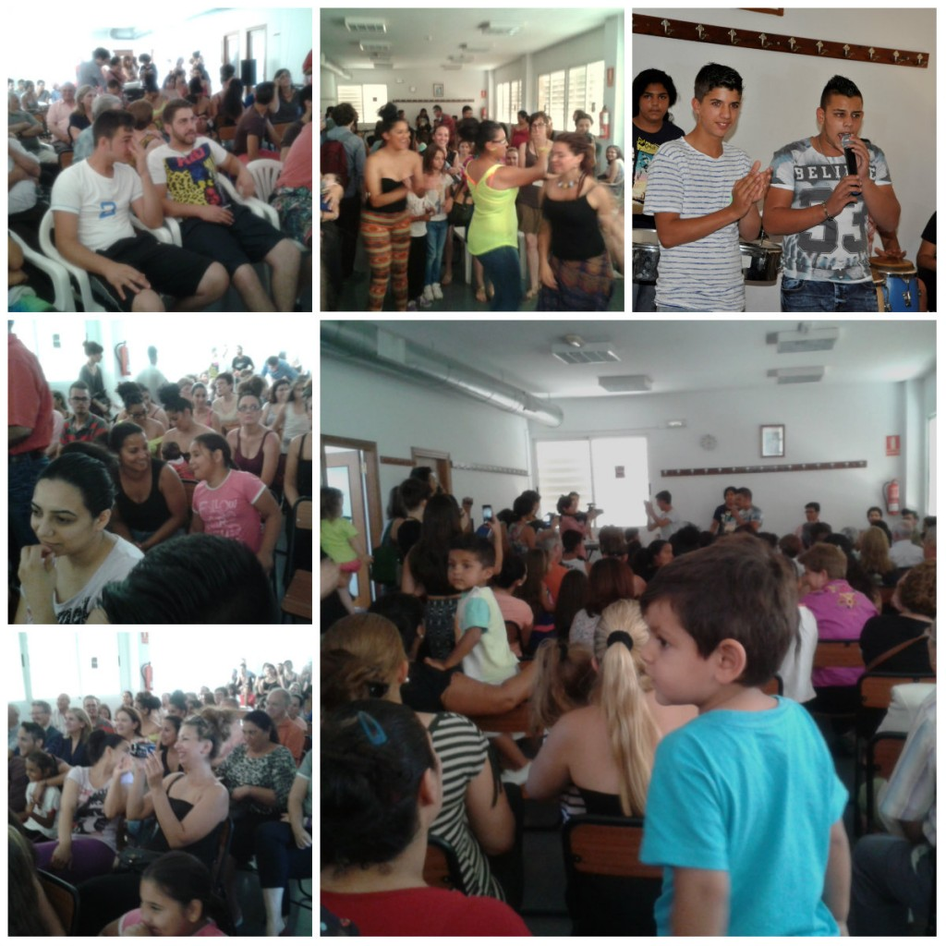

Source: Summer School web page http://globcons.uji.es/global_id

