TABLE 1: NUMBER OF TASKS PER LESSON (PAGE 12)

Lesson/Unit | Number of Tasks/Activities
1 | 3 (2 communication tasks, 1 focus on form task)
2 | 3 (2 communication tasks, 1 focus on form task)
3 | 4 (3 communication tasks, 1 focus on form task)
4 | 5 (4 communication tasks, 1 focus on form task)
Final Task | 1 (1 communication task)
Total | 16 (12 communication tasks, 4 focus on form tasks)

TABLE 2: TIME ALLOTTED FOR THE INTERVENTION MODULE (PAGE 13)

Unit/Lesson | Duration
1 | 4 ½ hours
2 | 4 ½ hours
3 | 4 ½ hours
4 | 4 ½ hours
Final Task | 1 hour

DISTRIBUTION OF THE TEACHING MODULE (PAGE 13)

Face to face classes | 19 sessions
Evaluation (pre and post-test) | 5 sessions

FACE TO FACE CLASSES (PAGE 13)

Face to face contact | 19 sessions
Group work | 14 sessions

DISTRIBUTION OF THE LANGUAGE SKILLS IN THE MODULE (PAGE 13)

Listening Comprehension | 15 sessions
Reading Comprehension | 15 sessions
Written Production | 15 sessions
Oral Production | 15 sessions

LANGUAGE AREAS (PAGE 13)

Practice of grammatical structures | 14 sessions
Vocabulary practice | 14 sessions

EVALUATION (PRE-TEST & POST-TEST) (PAGE 14)

Pre-test | 2 ½ sessions
Post-test | 2 ½ sessions

FIGURE 1: COMMUNICATION TASK (PAGE 15)

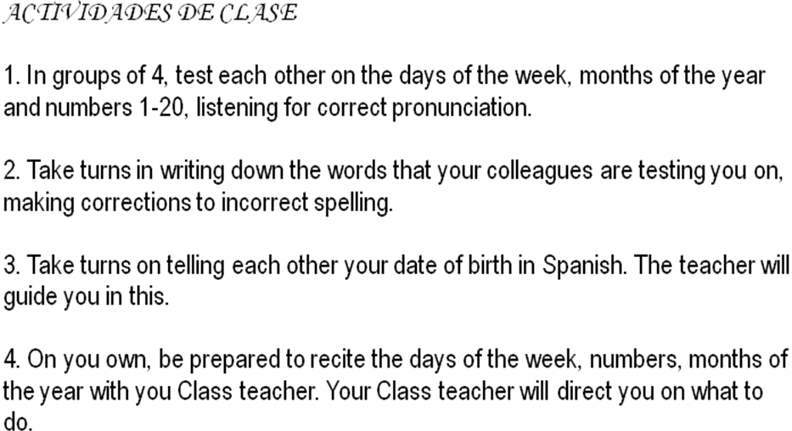

FIGURE 2: LANGUAGE SUPPORT (FOCUS ON FORM) TASK (PAGE 16)

Fill in the blanks determining which sentence will use SABER and which will use CONOCER, providing the correct form of the verb in each case. The first one has been completed for you.odel to Improve the Receptive and Productive Skills in S you.odel to Improve the Receptive and Productive Skills in S

1. Yo conozco a María Fuentes.

2. El hermano __________ español.

3. Mi tío ___________Argentina.

4. El padre de Julio __________ hablar.

5. Nosotros ___________a Señor Durante.

6. Tú ___________ de la Navidad (Christmas).

7. Nosotros ___________ donde está la iglesia.

8. Ellos ____________ al Presidente de Ghana.

TABLE 3: RESULTS OF THE PRE-TEST (FOUR LANGUAGE SKILLS) (PAGE 17)

S | Listening Comprehension (20%) | Reading Comprehension (20%) | Oral Production (30%) | Written Production  (30%) | Total  (100%)
1 | 8.1 | 10.09 | 14 | 15 | 47.19
2 | 6.05 | 6.80 | 14 | 16.90 | 43.75
3 | 10.9 | 9.23 | 11.2 | 19.07 | 50.4
4 | 11 | 9.25 | 15.75 | 19.38 | 55.38
5 | 10.2 | 8.36 | 16 | 18.57 | 53.13
6 | 8.5 | 10 | 11 | 16.12 | 45.62
7 | 5.5 | 7 | 11.6 | 19.65 | 43.75
8 | 7 | 9 | 12.88 | 18.62 | 47.5
9 | 9.8 | 8.75 | 12 | 16.33 | 46.88
10 | 8 | 6.25 | 12 | 12.19 | 38.44
11 | 8.05 | 8.07 | 16 | 17.26 | 49.38
12 | 9.8 | 9.2 | 17 | 19.88 | 55.88
13 | 8.9 | 8.06 | 16 | 18.92 | 51.88
14 | 10 | 9.68 | 16.5 | 20.07 | 56.25
15 | 11.5 | 9.06 | 9.5 | 11.82 | 41.88
16 | 9.7 | 8.88 | 12 | 12.42 | 43
17 | 8.6 | 8.5 | 12.9 | 18.13 | 48.13
18 | 10.9 | 8.94 | 15.8 | 20.92 | 56.56
19 | 8.4 | 8.75 | 12.7 | 15.65 | 45.5
Average | 8.99 | 8.62 | 13.62 | 17.21 | 48.45

FIGURE 3: AVERAGE PERFORMANCE BY LANGUAGE SKILL IN THE PRE-TEST (PAGE 17)

TABLE 4: TOTAL SCORE OBTAINED IN THE POST-TEST (FOUR LANGUAGE SKILLS) (PAGE 18)

S | Listening Comprehension (20%) | Reading Comprehension (20%) | Oral Production (30%) | Written Production  (30%) | Total  (100%)
1 | 15 | 17 | 27 | 23.53 | 82.53
2 | 17 | 17.55 | 26 | 28 | 88.55
3 | 12.5 | 13.7 | 22.5 | 16.8 | 65.5
4 | 17 | 18.5 | 24.5 | 23.43 | 83.43
5 | 13.8 | 12.5 | 19 | 18.25 | 63.55
6 | 16.5 | 19 | 20.5 | 28.94 | 84.94
7 | 10 | 14.5 | 19.5 | 15.19 | 59.19
8 | 15.5 | 13 | 23 | 20.78 | 72.28
9 | 16 | 11.6 | 28.5 | 21.91 | 78.01
10 | 12 | 15 | 23 | 18.73 | 68.73
11 | 13.05 | 14.8 | 22.5 | 22.09 | 72.44
12 | 15.8 | 18.2 | 22 | 20.96 | 76.96
13 | 14 | 12 | 26 | 26.61 | 78.61
14 | 13.6 | 19.1 | 23 | 17.19 | 72.89
15 | 16 | 16 | 18 | 17.55 | 67.55
16 | 11.5 | 13.2 | 24 | 21.8 | 70.5
17 | 16.8 | 17 | 18.5 | 17.58 | 69.88
18 | 19 | 20 | 23.5 | 21.84 | 84.34
19 | 11 | 16.8 | 20 | 17.2 | 65
Average | 14.53 | 15.76 | 22.68 | 20.97 | 73.94

FIGURE 4: AVERAGE PERFORMANCE BY LANGUAGE SKILL IN THE POST-TEST (PAGE 19)

FIGURE 5: AVERGAES ACHIEVED IN THE PRE-TEST AND POST-TEST
(PAGE 20)

FIGURE 6: DIFFERENCE BETWEEN PERFORMANCE BY LANGUAGE SKILL IN PRE-TEST AND POST-TEST (PAGE 20)

